1. **Create a pipeline named 'GetMetaData_Example' to fetch the list of all the files available inside the ADLS folder.**

Solution:

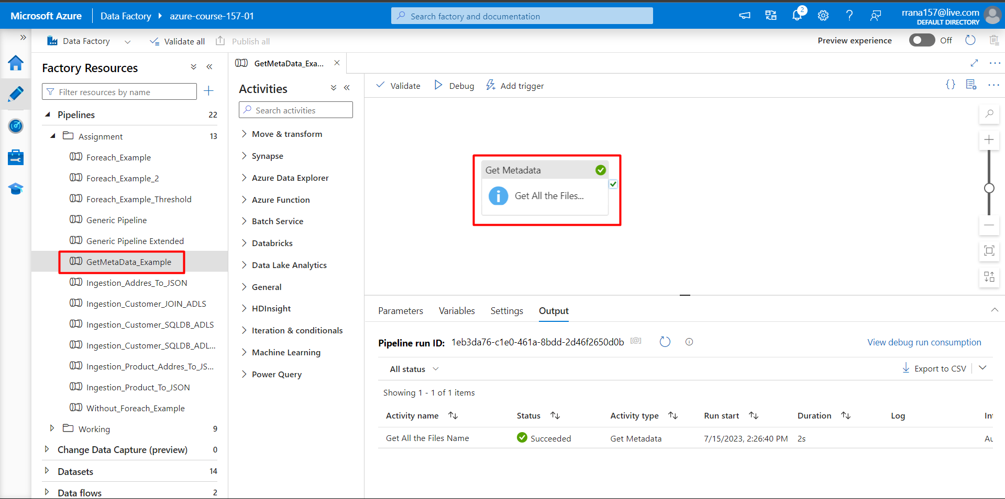

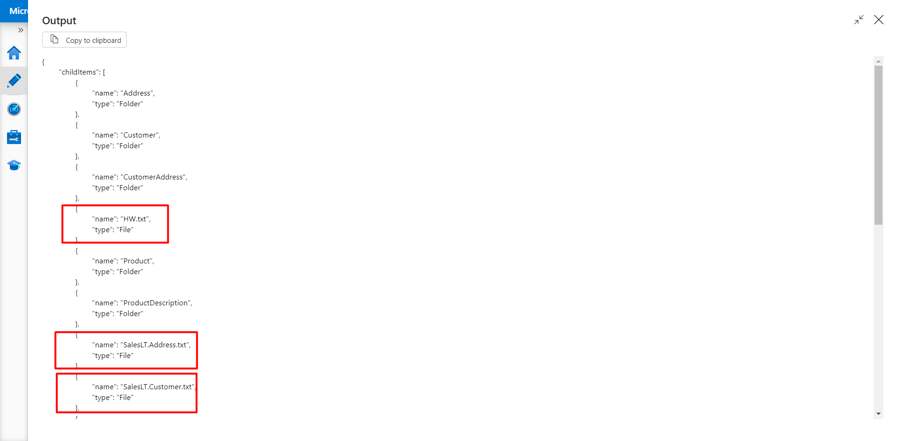

1. **Create a pipeline name 'Foreach_Example' to copy the Customer & Customer address table data into ADLS using the one copy activity.**

Solution:

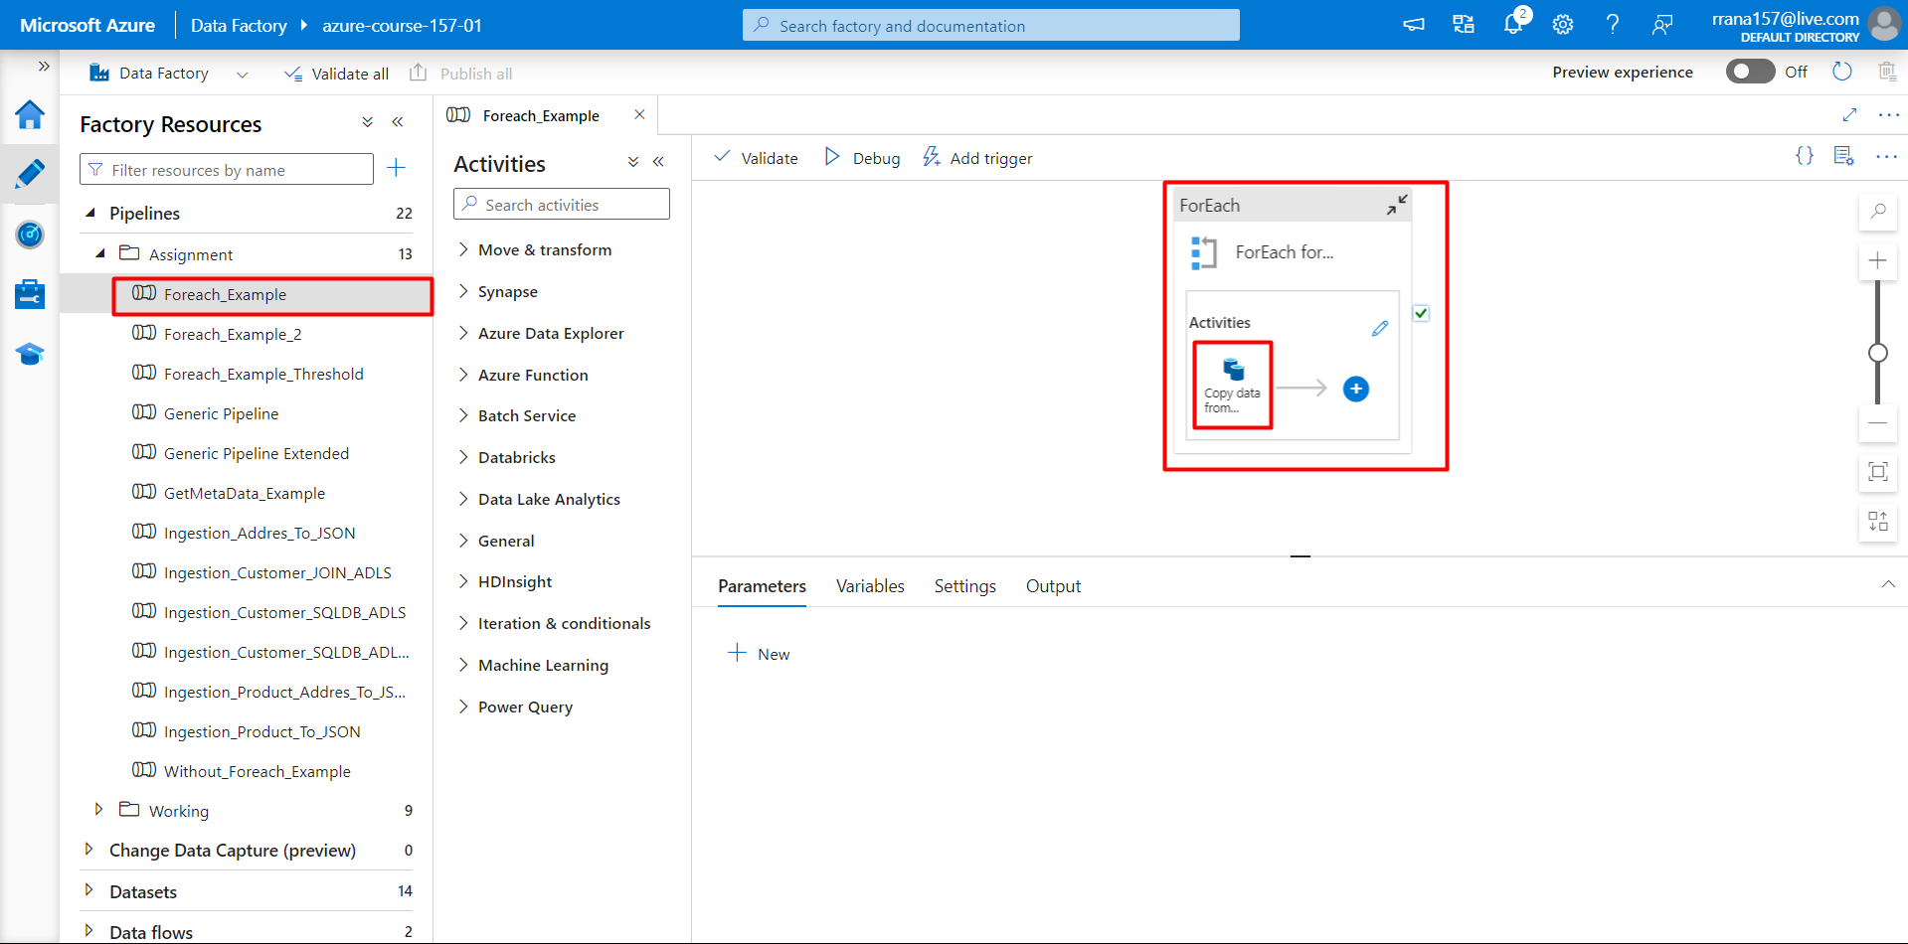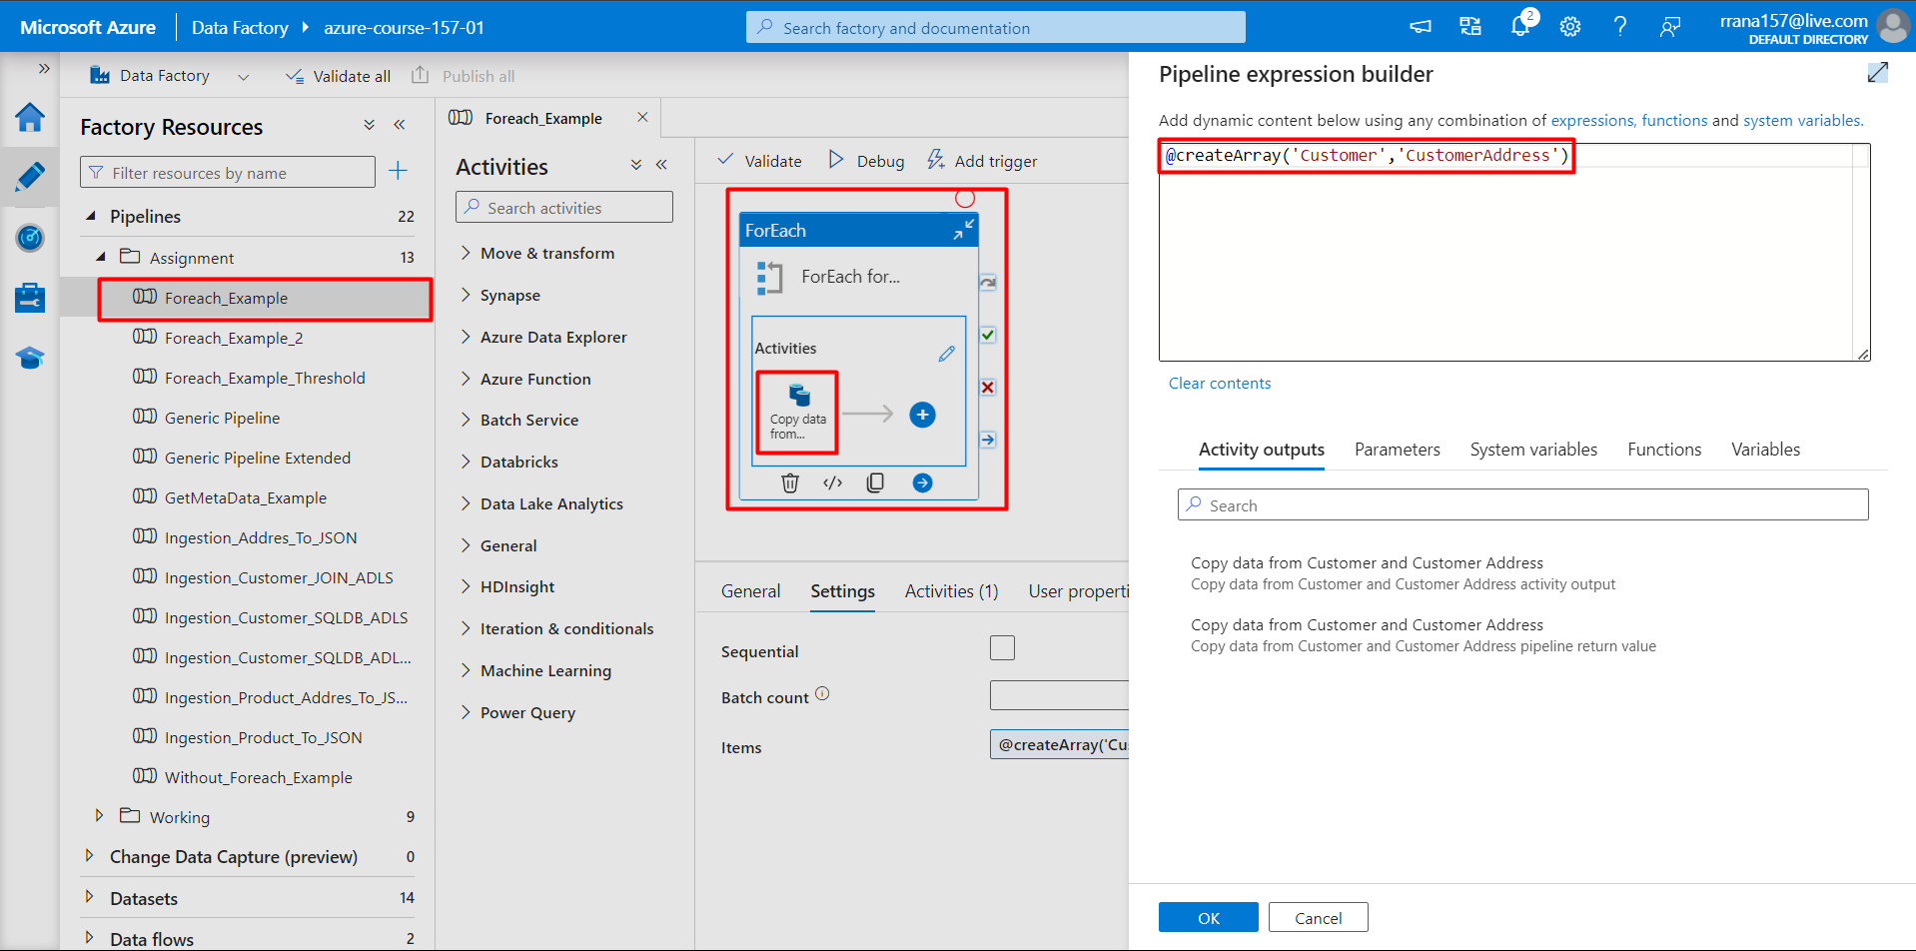

## Create a pipeline that first checks whether the Customer.csv file is available in the folder location. If it is available, it will copy the file data to the Customer Table.

Solution:

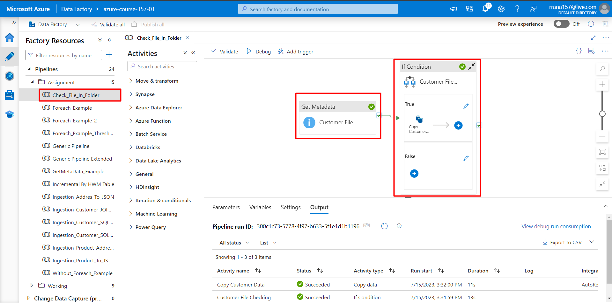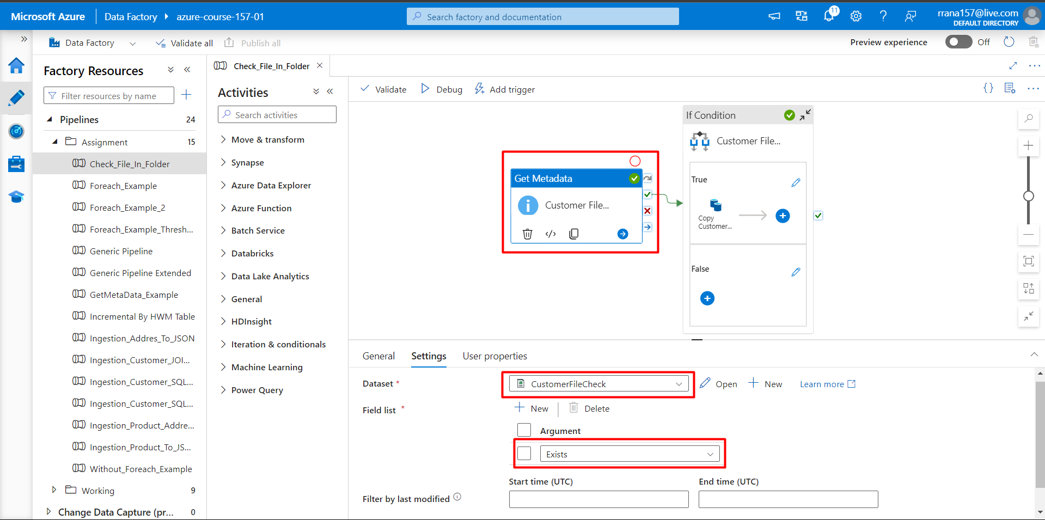

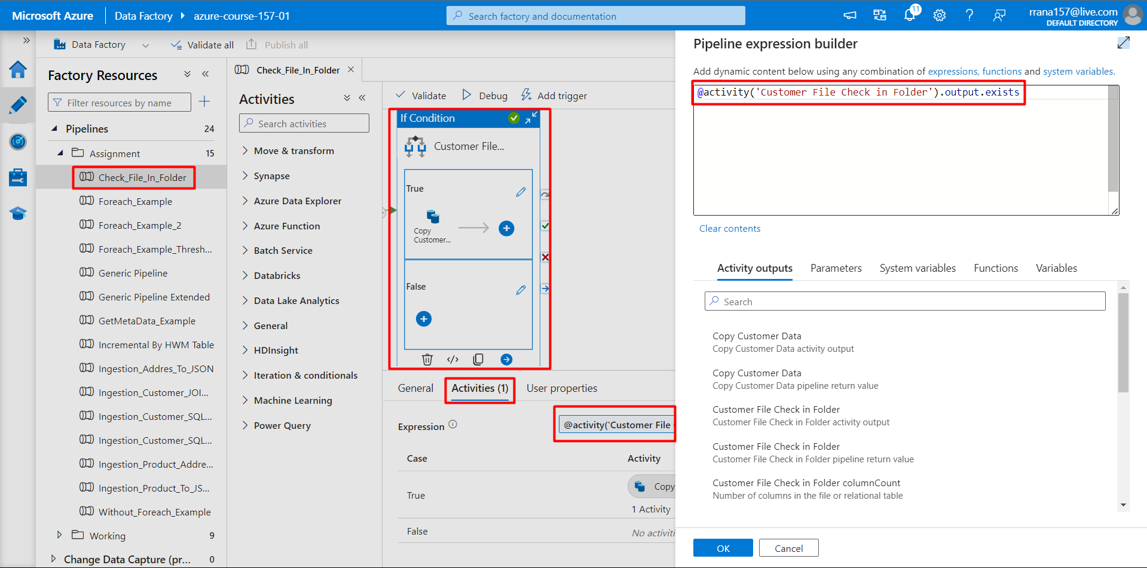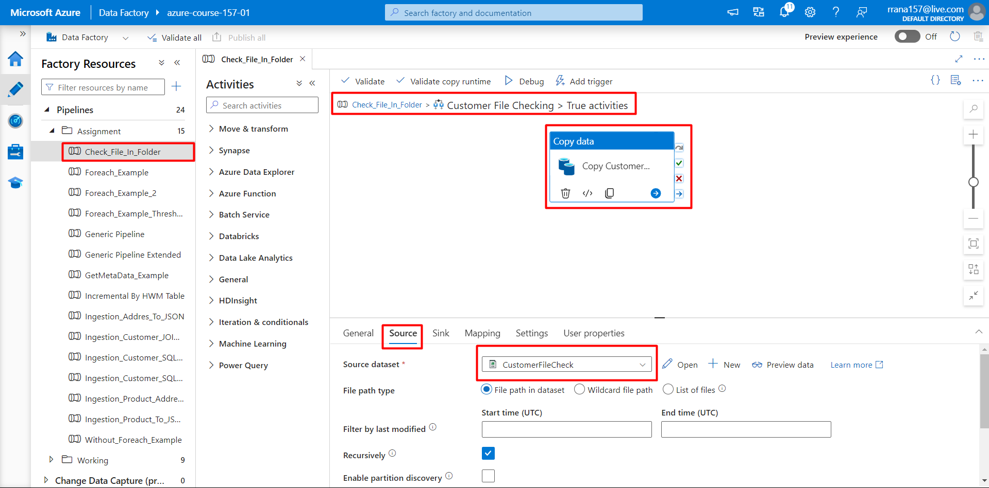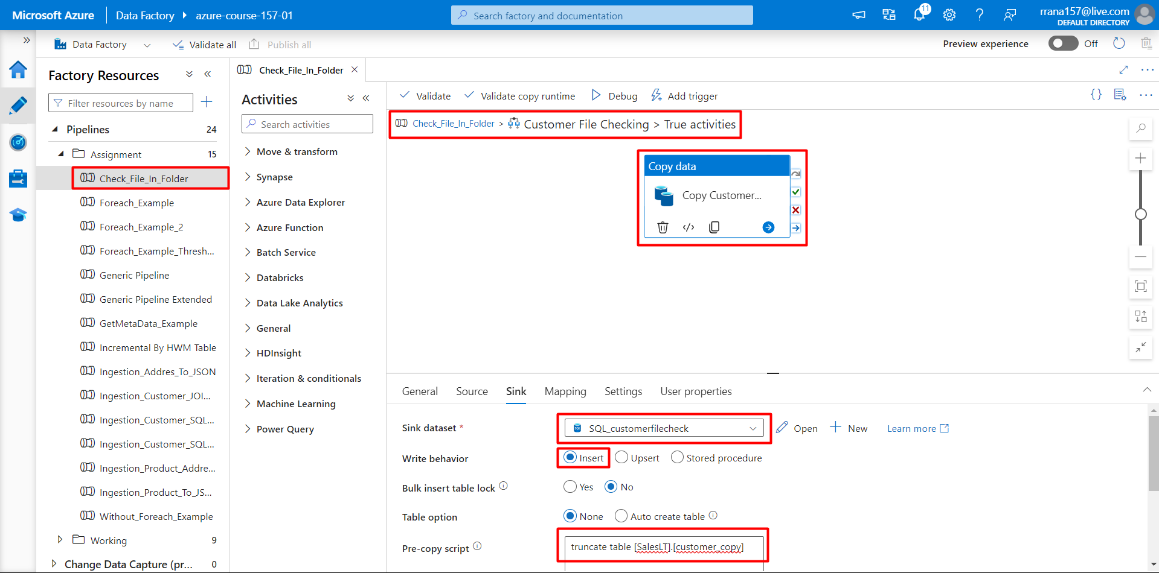

## Create a pipeline that will create the incremental pipeline using the table instead of HighWaterMark File.

Solution: 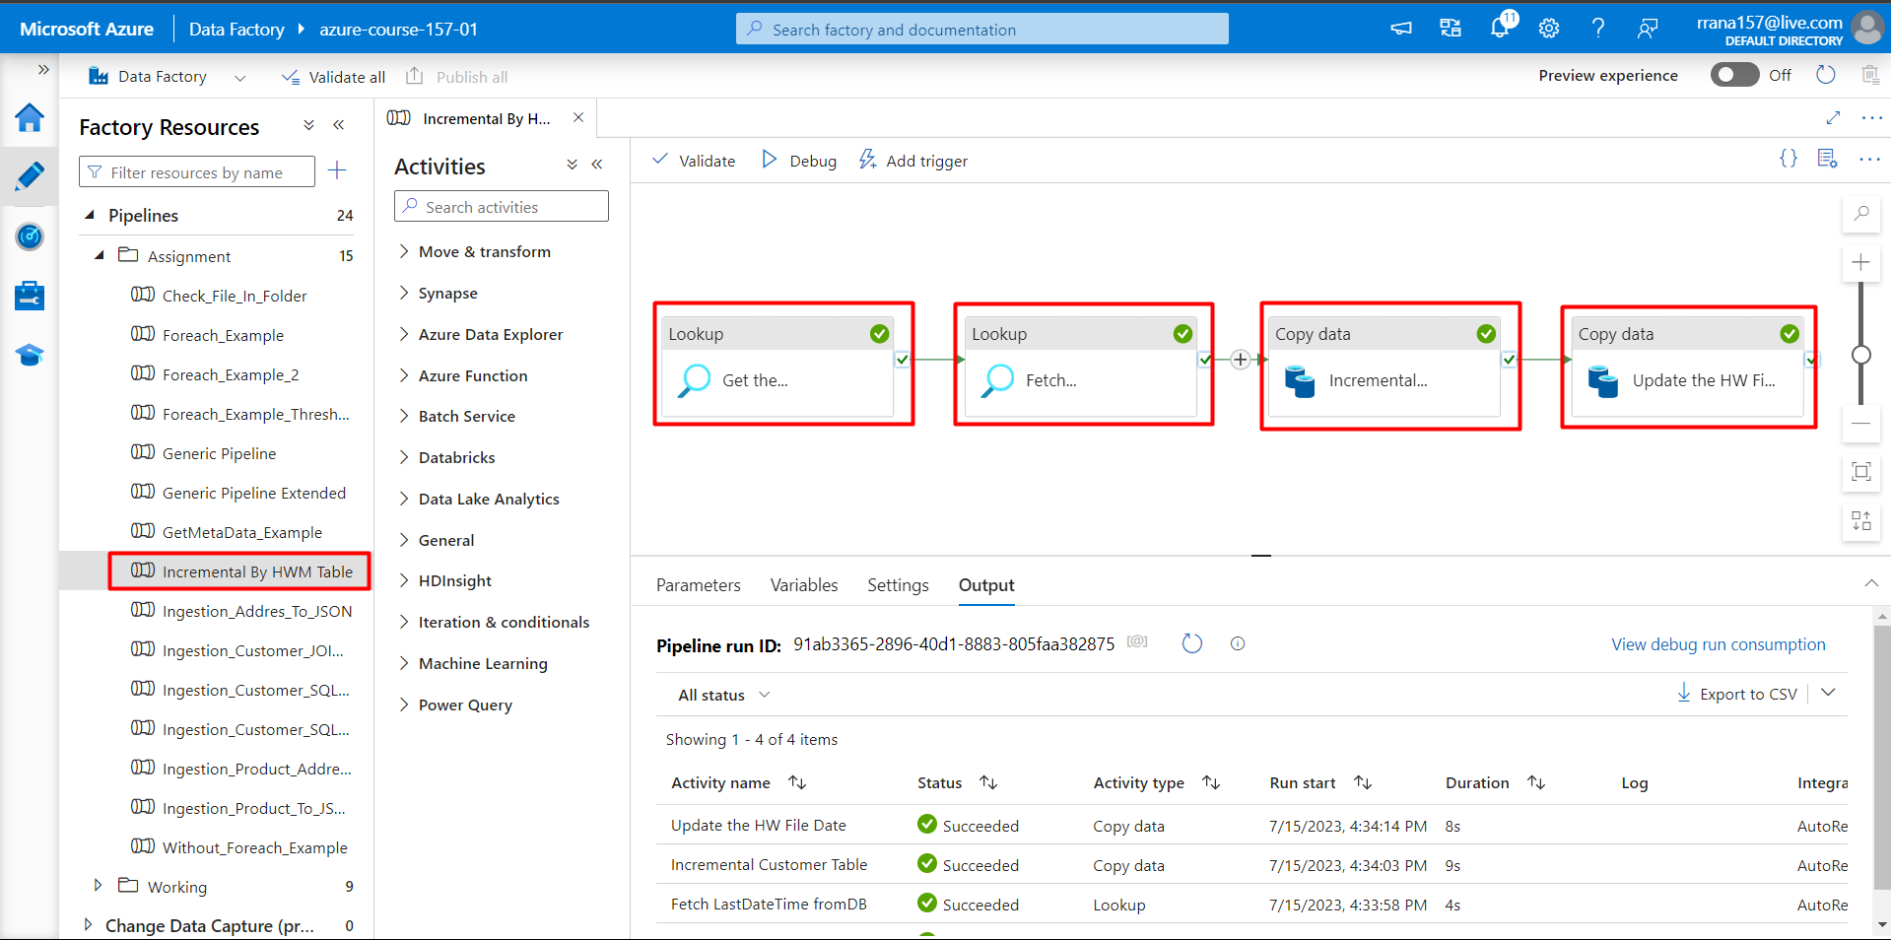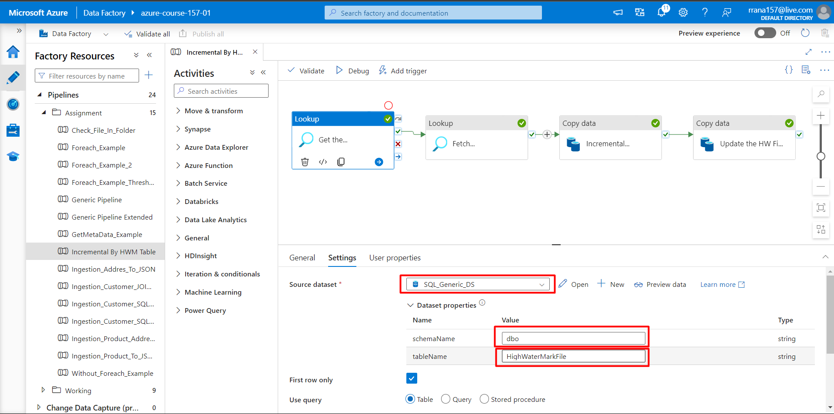

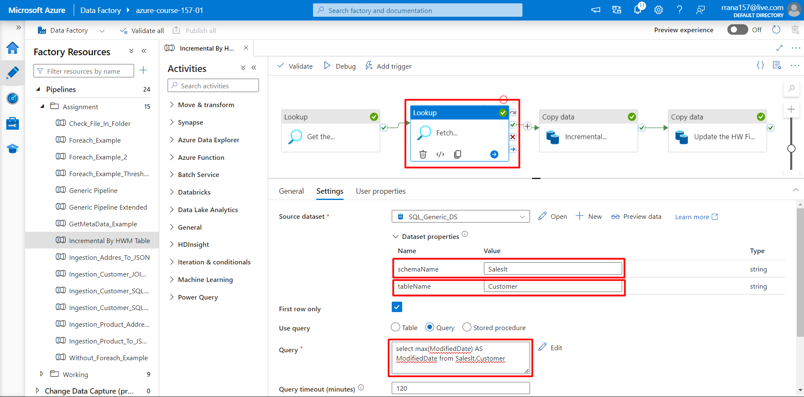

## 

## Create a pipeline name 'Foreach_Example2' to copy the below information using just one copy activity.

## - All the product table data where productid > 100

## - All the customer table data where Customer id>100 and Customer id <1000

Solution:

